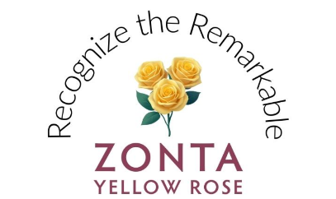
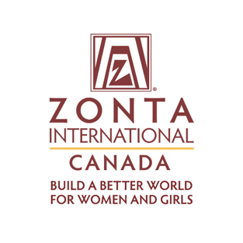
Rationale & Yellow Rose Campaign Toolkit: Zonta Yellow Rose Campaign – Integrating Month-Long Yellow Rose Campaign alongside International Women’s Day, March 8th
The overlap of Zonta Rose Day and International Women’s Day has sometimes presented challenges as we work to create sustainable campaigns that extend beyond each biennium. Although we can capitalize on the visibility of International Women’s Day (March 8, 2026), restricting our fundraising and awareness activities to only Zonta Rose Day limits the flexibility and impact our members can achieve.
To address these challenges, we are expanding our celebration to encompass the entire month of March. While this may seem like a shift from tradition, it aligns with how many of our clubs already celebrate Zonta by holding their Rose Day events before and after 8 March. International Women’s Day will remain a key focal point for our global causes and visibility efforts, but now the entire month will serve as a time to honour Zonta and the remarkable women who deserve recognition.
Goals:
- Raise funds for the Foundation by encouraging donations in recognition of remarkable women who have inspired members and donors. (Goal: US$100,000).
- Engage local communities by showcasing the benefits of Zonta at Yellow Rose events and International Women’s Day events.
- Inspire members to take actions that align with the Core Values of Zonta while enjoying the benefits of membership by having them play a Zonta customized game of "Bingo" throughout the month of March.
- Showcase women affiliated with Zonta by highlighting our Remarkable Women, Powerful Stories podcast guests and International Honorary Members.

Yellow Rose Campaign Toolkit to help achieve the above goals:
- Zonta Foundation for Women Donate Now link
- Zonta International Website: Zonta Yellow Rose Campaign Link
- Zonta International Core Values Link to Document
- Donation Postcard |Canva Template Link
- Event flyer template | Canva Template Link
- Zonta Yellow Rose Campaign Logo | .jpeg | .png
- Zonta Yellow Rose Bingo | coming soon
- Women of Impact in Canada Crossword | Link | Answer Link
- Remarkable Women, Powerful Stories podcast | Link
- International Honorary Members | Link

