
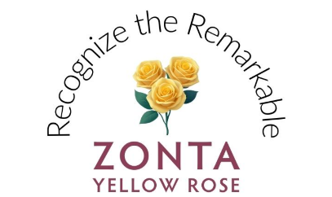
Recognize the Remarkable
Zonta Yellow Rose Campaign: March 2026
and International Women's Day, 8 March 2026
We celebrate 8 March as International Women’s Day and the whole month for the Zonta Yellow Rose Campaign!
As Zonta’s longstanding symbol of friendship, the yellow rose invites us to reflect upon and recognize the remarkable women and girls whose generosity, resilience and leadership bring our mission to life every day.
Together, donors, beneficiaries, and awardees form the living legacy of Zonta’s impact. Each gift, whether large or small, represents more than financial support. It reflects trust in Zonta’s vision and confidence in the power of collective giving.
The Zonta Yellow Rose Campaign is a celebration and a call to recognize the remarkable efforts that drive meaningful change. By honouring the individuals who bring our mission to life, we reaffirm our shared belief that empowering women and girls empowers the world.
Whom will you recognize this March?

HOW TO RECOGNIZE THE REMARKABLE:
- Make a donation to the Zonta Foundation for Women in recognition of remarkable women who have inspired you.
- Attend a local Zonta Yellow Rose or International Women’s Day event to meet members and learn how Zonta benefits the community.
- See how remarkable you are by playing Zonta "Bingo" throughout the month of March.
- Recognize Zonta's remarkable women by listening to our Remarkable Women, Powerful Stories podcast and learning more about our International Honorary Members.

