IWD & Yellow Rose Campaign: Social Media & Club Engagement Toolkit
Outlines for social media posts or club presentations (URLs link to full bios & photos)
Theme: Women in Leadership (Decision Making)
Potential Social Post Headline: Celebrating Leadership in Action: Honouring Women Who Inspire Change.
First Post:
This International Women’s Day, Zonta Canada (or insert club name) celebrates the women who inspire change through leadership. We shine a spotlight on those who challenge the status quo, elevate voices, and drive meaningful progress in our communities.
We honour the women who make an impact every day through courage, innovation, and unwavering determination. Together, we are building a future where every woman has the opportunity to lead, inspire, and thrive.

Following Posts or for Presentations:
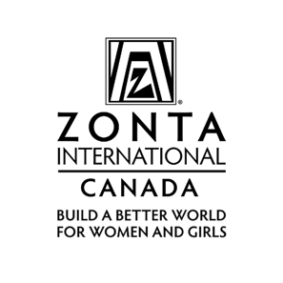
IWD Zonta Canada Women in Leadership
(Decision Making Roles)
Short headline: Great for posters, emails, social graphics.
Celebrating Leadership in Action: Honouring Women Who Inspire Change.
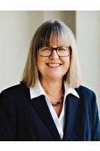
Post: Dr. Donna Strickland – Canadian Physicist & Nobel Laureate
Today, we honour Dr. Donna Strickland — a trailblazing Canadian physicist and 2018 Nobel Laureate whose development of chirped pulse amplification (CPA) revolutionised ultra-intense laser technology. Her work impacts fields from industry to vision-saving eye surgery.
A leader in science. A force for innovation. A woman who inspires.
#IWD2026 #ZontaCanada #WomenInSTEM #NobelPrize #CanadianExcellence #WomenWhoLead #InspireInclusion
Photo & bio: University of Waterloo; Nobel Prize. [uwaterloo.ca], [nobelprize.org] (Photo credit University of Waterloo)
Post: Dr. Katalin Karikó – Biochemist & Nobel Laureate
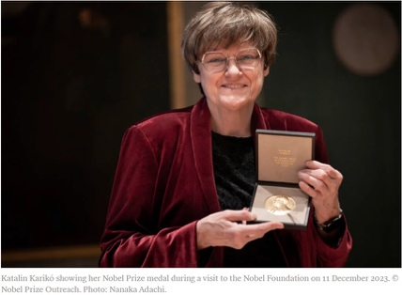
Dr. Katalin Karikó’s groundbreaking work in nucleoside-modified mRNA enabled the creation of effective mRNA vaccines — a scientific achievement that changed the course of global health. As a 2023 Nobel Laureate, her leadership in research continues to save lives worldwide.
Her perseverance reshaped medicine. Her impact is felt globally.
#IWD2026 #ZontaCanada #WomenInScience #NobelPrize #mRNA #WomenWhoImpact #InspireInclusion
Photo/bio: NobelPrize.org; Britannica. [nobelprize.org], [britannica.com] Photo credit: Nanaka Adachi

Post: Malala Yousafzai – International Education Activist & Nobel Peace Prize Laureate
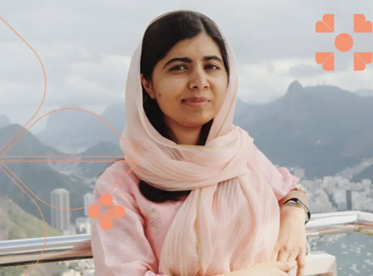
Malala Yousafzai has become a global voice for girls’ right to learn. As the youngest-ever Nobel Peace Prize Laureate and co-founder of the Malala Fund, she champions access to safe, quality education for every girl, everywhere.
Her courage sparked a movement. Her leadership empowers millions.
#IWD2026 #ZontaCanada #GirlsEducation #Malala #WomenHumanRights #WomenWhoInspire
Photo/bio: NobelPrize.org; Malala Fund. [nobelprize.org], [malala.org]
Photo courtesy of Malala Fund

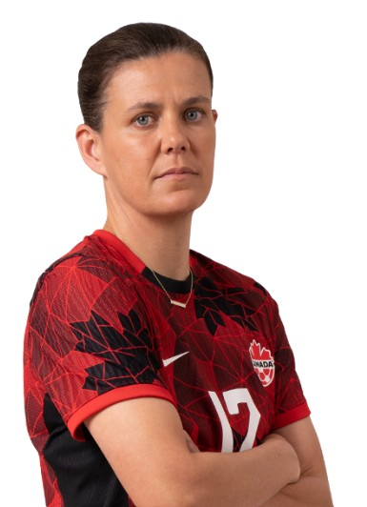
POST: Christine Sinclair – Canadian Soccer Legend
Christine Sinclair — Olympic gold medallist, long-time captain of Canada Soccer’s Women’s National Team, and the world’s all-time international goals leader (190) — transformed the landscape for women’s sport in Canada and beyond.
A champion on the field. A leader for future generations.
#IWD2026 #ZontaCanada #ChristineSinclair #WomenInSport #CanadianIcons #LeadTheWay
Photo/bio: Canada Soccer; Olympics.com. [canadasoccer.com], [olympics.com] Photo courtesy of Canada Soccer

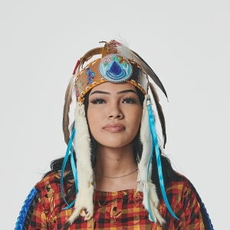
Post: Autumn Peltier – Anishinaabe Water Rights Advocate
At just 13, Autumn Peltier stood before the UN General Assembly demanding clean water for all. Now the Anishinabek Nation’s Chief Water Commissioner, she is a global advocate for Indigenous water protection.
Young leadership. Powerful voice. Unwavering advocacy.
#IWD2026 #ZontaCanada #IndigenousLeaders #WaterRights #YouthLeadership #WomenWhoLead
Photo/bio: The Canadian Encyclopedia; Wikipedia. [thecanadia...lopedia.ca], [en.wikipedia.org]
Photo credit_jessicadeeks_National Arts Centre

Post: Dr. Cindy Blackstock – Indigenous Children’s Rights Advocate
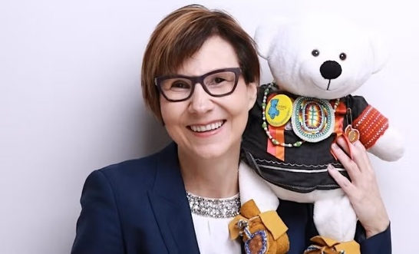
Dr. Cindy Blackstock, a Gitxsan scholar and Executive Director of the First Nations Child & Family Caring Society, led the landmark human rights case that advanced Jordan’s Principle and transformed supports for First Nations children.
A fierce defender of equity. A champion for children’s rights.
#IWD2026 #ZontaCanada #IndigenousRights #ChildAdvocacy #WomenWhoImpact #InspireInclusion
Photo/bio: Caring Society; Canada.ca. [fncaringsociety.com], [canada.ca]
Photo courtesy of (photo courtesy of U Waterloo speaking engagement Spirit Bear's Guide to Reconciling History June 2003)

Reshma Saujani – Founder, Girls Who Code & Moms First
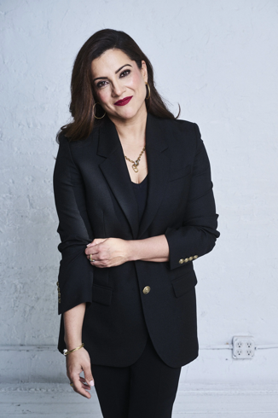
Reshma Saujani is reshaping the future of work and technology. As founder of Girls Who Code, she champions gender equity in tech, and through Moms First, she advocates for structural support for working mothers.
Her leadership is closing gaps and creating opportunities.
#IWD2026 #ZontaCanada #GirlsWhoCode #WomenInTech #WorkingMothers #EquityMatters #WomenWhoInspire Photo/bio: ReshmaSaujani.com; Girls Who Code bio. [reshmasaujani.com], [girlswhocode.com] Photo courtesy of reshmasaujani.com

Post: Dr. Ngozi Okonjo-Iweala – Director-General, WTO
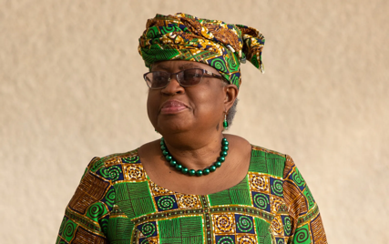
Dr. Ngozi Okonjo-Iweala made history as the first woman and first African Director-General of the World Trade Organization. A globally respected economist, she drives progress on inclusive trade and economic resilience.
A global leader forging pathways for women in governance.
#IWD2026 #ZontaCanada #WomenInLeadership #GlobalEconomy #NgoziOkonjoIweala #InspireInclusion
Photo/bio: Britannica; Wikipedia. [britannica.com], [en.wikipedia.org]
Photo credit -WTO-Director-General-2021photo credit Canadian Britannica.com)

Post: Dr. Hayat Sindi – Biotechnologist & Global Innovator
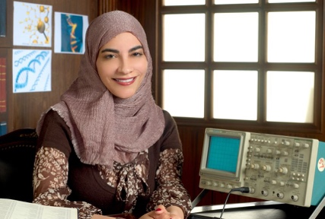
Dr. Hayat Sindi is a pioneering Saudi biotechnologist and UNESCO Goodwill Ambassador for Science, Technology & Innovation. As co-founder of Diagnostics for All, she is expanding access to low-cost, life-saving health technologies worldwide.
Innovation for equity. Science for everyone.
#IWD2026 #ZontaCanada #WomenInSTEM #GlobalHealth #HayatSindi #WomenWhoImpact
Photo/bio: National Geographic Education; UNESCO article. [education....raphic.org], [unesco.org]
Photo credit Hayat Sindi for National Geographic Education


Post: Dr. Nadine Rena Caron – First Nations Surgeon & Health Leader
Dr. Nadine Rena Caron made history as Canada’s first female First Nations general surgeon. As co-founder of UBC’s Centre for Excellence in Indigenous Health and FNHA Chair in Cancer & Wellness, she’s advancing equitable health care for Indigenous communities.
A leader in medicine. A champion for culturally safe care.
#IWD2026 #ZontaCanada #IndigenousHealth #WomenInMedicine #NadineCaron #LeadWithImpact
Photo/bio: The Canadian Encyclopedia; Canada.ca. [thecanadia...lopedia.ca], [canada.ca] (Photo credit CanadianEnclypedia.ca)

Post: Roberta Bondar – First Canadian Woman Astronaut
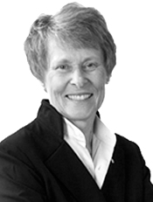
In 1992, Dr. Roberta Bondar became the first Canadian woman astronaut to be sent into space. A respected neurologist, medical researcher and educator, Bondar is also an accomplished pilot, professional fine art landscape photographer, author, environmentalist and motivational speaker. She’s served for more than a decade as NASA's head of space medicine. An inspiring leader and role model, Bondar is an Officer of the Order of Canada, appointee to the Order of Ontario and holds the NASA Space Medal. She has been inducted into the International Women's Forum Hall of Fame and the Canadian Medical Hall of Fame and has received 24 honorary doctorates.
“I realize it’s not about me; it’s about what I did and about the person we had as a Canadian woman in space. I look at pictures of myself and say, ‘That’s the woman who did it.’”

Photo credit The Roberta Bondar Foundation

Post: Sara L. Austin - advocate for children’s rights
Founder & CEO of Children First Canada, leading a national movement to make this country the best place in the world for kids to grow up.
She shaped major public policy and global change, including a campaign that helped create the UN Optional Protocol on a Communications Procedure (OP3) — a groundbreaking law now used by Greta Thunberg and other youth to hold governments accountable.
She also led the development of the Canadian Children’s Charter, the annual Raising Canada report spotlighting the top threats to childhood, and the launch of the Young Canadians’ Parliament.
Her career includes leadership roles with the Sheldon Kennedy Child Advocacy Centre, World Vision Canada, and the UN’s Global Advisory Council on Violence Against Children. She’s a two-time Top 25 Women of Influence award recipient and the youngest inductee into the Top 100 Most Powerful Women Hall of Fame.

Sara holds an MSt/LLM in International Human Rights Law from Oxford and an Honours BA from Dalhousie University.
Photo credit: Leigha Graf Photography

